# General Guidelines for using the Community Readiness Assessment for Community Services Boards (CSBs) with Multiple Localities

The Community Readiness Assessment is an evidence-based tool, so when we make adaptations for CSBs working with multiple localities, we want to balance this adaptation with continued focus on fidelity to other core elements of the model. **Please be aware that this does not pertain to all CSBs**, only those that serve multiple localities (usually cities/counties) where adaptation may be necessary.

If you are unsure of how to approach the Community Readiness Assessment for your CSB’s catchment area, please review the recommendations below and then reach out to your OMNI TA Consultant for individualized TA around these recommendations.

In order to adapt the Community Readiness Assessment to fit CSBs that serve multiple localities, please keep these guidelines in mind:

**Continued focus on fidelity to other core elements of the model:**

* **Core Element: Define the issue**As stated in the Tri-Ethnic Center Handbook, “Readiness is issue specific.” The issue addressed in the key informant interviews should be clearly defined by your Needs Assessment Team before conducting the interviews. Keep in mind that defining the issue more broadly, such as "Underage substance use, including alcohol, tobacco and all other drugs," will produce more general readiness results than an issue defined more specifically, such as "Binge drinking among high school students," which will produce more targeted readiness results. Please refer to pages 12 - 15 in the handbook.
* **Core Element: Diversity of respondents**In order to best represent the diversity within your CSB catchment area, please ensure that respondents (interviewees) represent a diversity of sectors. Please refer to pages 18 – 23 in the handbook. We recommend at least two interviewees per locality. When conducting a survey for your entire CSB catchment area, consider prioritizing sector representatives that have a regional perspective (for example, perhaps a public health provider that serves several localities, or a cooperative educational service that provides mental health services to several school districts, or a law enforcement official that works in more than one of the localities.)
* **Core Element: Define the community**

As the Tri-Ethnic Center Handbook explains, “Readiness is community specific.” This is the element that requires careful thought when conducting an assessment for a CSB with multiple localities. You will need to decide what geographic community is being assessed. This geographic community should be defined for the interviewee and emphasized throughout the interview. If some respondents are asked to comment on the CSB catchment area, and others are asked to comment on a specific locality, you cannot combine their scores and maintain fidelity to the model. Please refer to page 13 - 15 in the handbook.

Here are two examples of how you may wish to conduct the community readiness interviews and scoring process:

**Example 1: CSB with 4 localities (Counties A, B, C, and D)**

* + - Counties A and C are more similar due to their rural settings.
    - Counties B and D are more similar due to their urban centers.
    - Therefore, the CSB splits their catchment area into two communities for the community readiness assessment.

**Example 2: CSB with 6 localities**

The CSB catchment area covers 6 counties and cities, and the CSB chooses to assess the entire CSB catchment area as one community for the community readiness assessment.

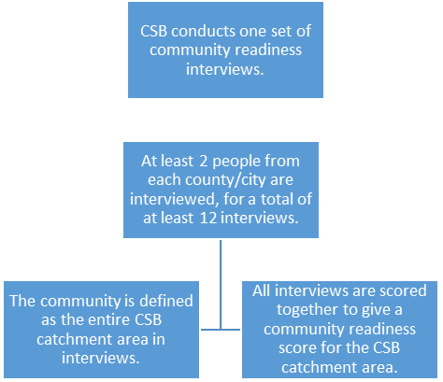

With an adaptation of the Community Readiness Assessment for multiple localities**, it is particularly important to outline that adaptation within the Final Needs Assessment Report** so that readers know how the community was defined for respondents.

Again, please don’t hesitate to reach out to your OMNI consultant with any questions about customizing the Community Readiness Assessment.